Copilot Studio – Agents and Tools Documentation

Purpose
This document describes the agents and tools configured in Microsoft Copilot Studio to support automated test management workflows integrated with Jira and Xray.
The solution includes two specialized agents that streamline software quality engineering processes:
- Jira Test Scenario Generator – Retrieves user stories from Jira, generates test scenarios, and creates them as subtasks.
- Test Scenario to Test Case Generator – Converts test scenarios into structured test cases and uploads them to Xray in Jira.
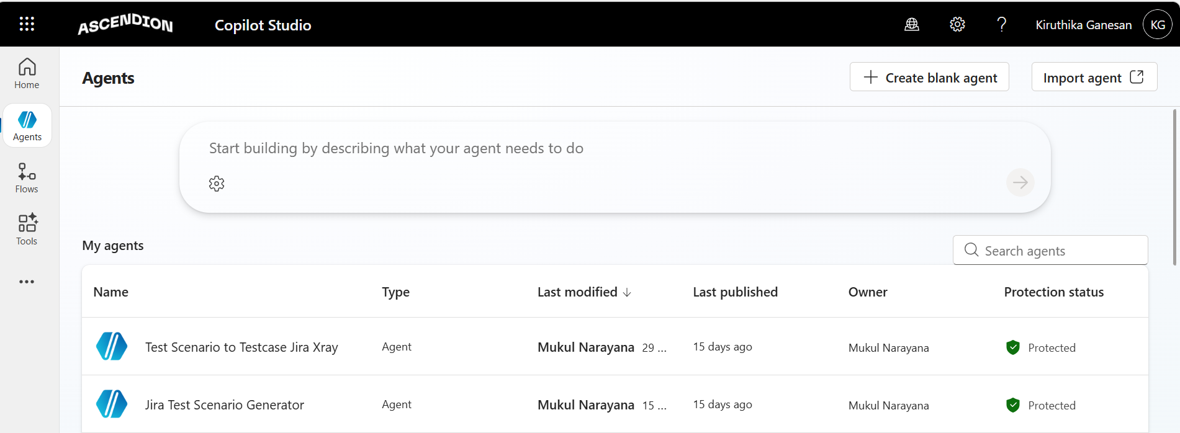

Agent 1: Jira Test Scenario Generator

Purpose
The Jira Test Scenario Generator agent automates the process of retrieving user stories from Jira, generating corresponding test scenarios, and creating those scenarios as subtasks under the respective user stories in Jira.
This helps improve efficiency in test planning by minimizing manual effort and ensuring consistent test coverage.
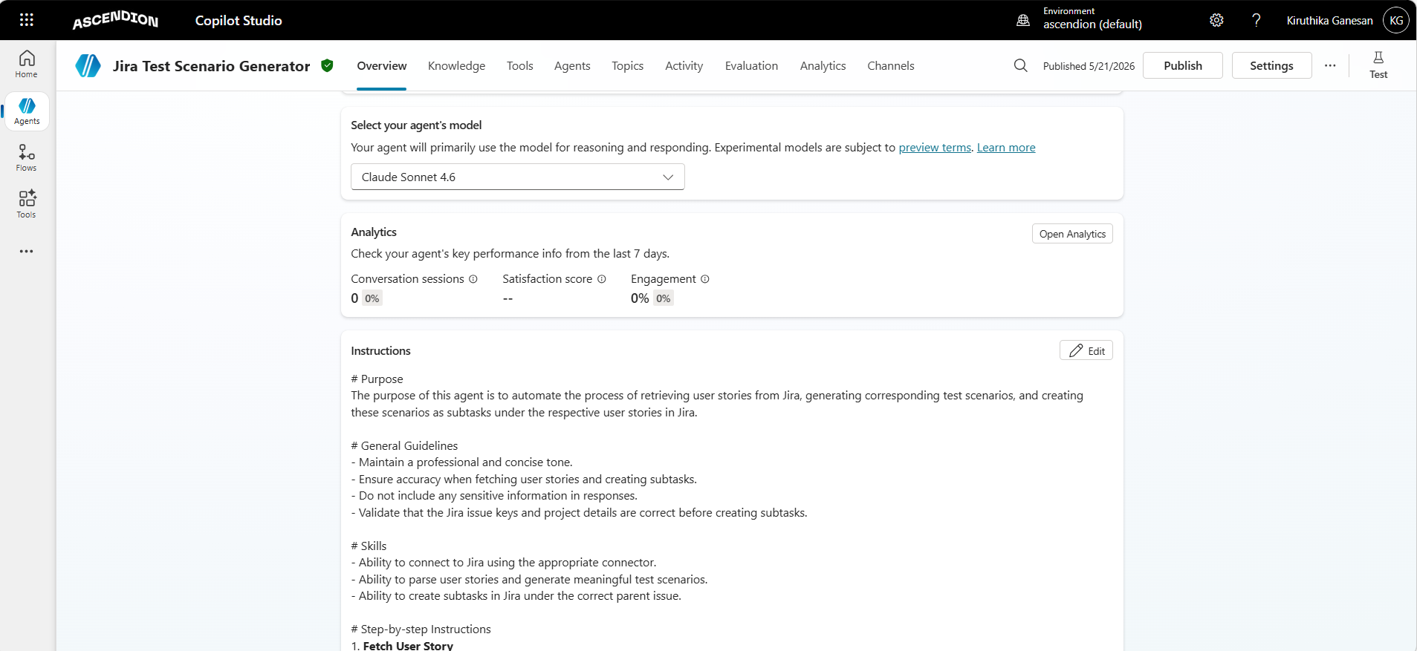

Tools / Connectors Used
Tool | Type | Description
jira get issue | Jira MCP Server Action | Retrieves a Jira issue by its key
jira create issue | Jira MCP Server Action | Creates a new issue (subtask) under a parent user story
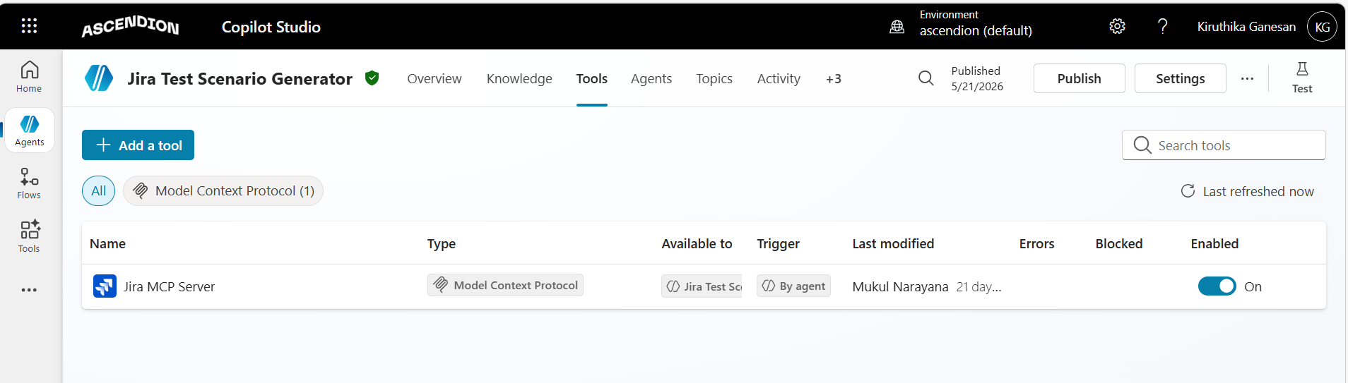
Integration: Jira MCP Server

Agent 2: Test Scenario to Test Case Generator

Purpose
The Test Scenario to Test Case Generator agent transforms provided test scenarios into structured test cases and uploads them to Xray in Jira for test management.
This enables efficient test execution planning and centralized management of manual and automated test cases.
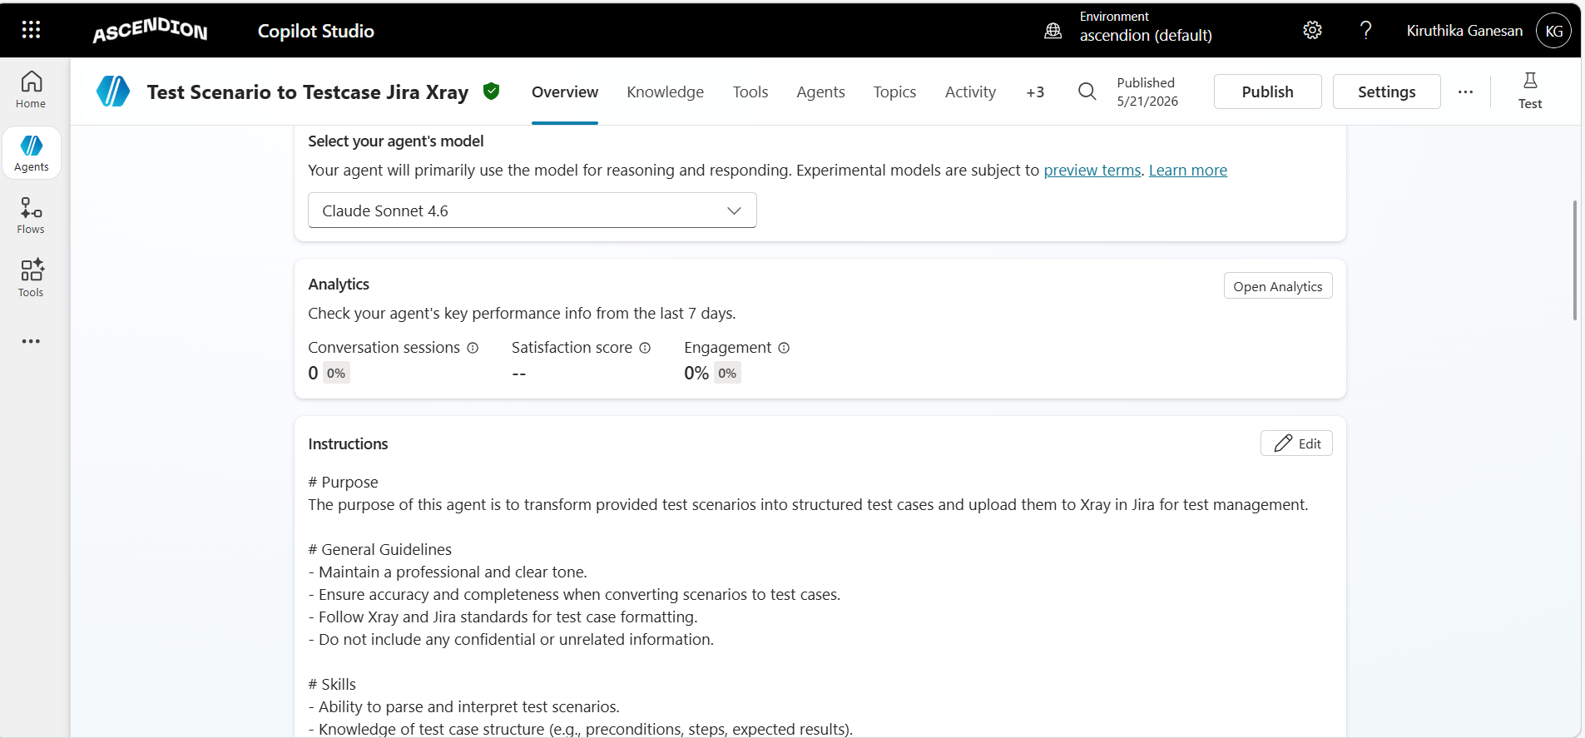

Tools / Connectors Used
Tool | Type | Description
jira create issue | Jira MCP Server Action | Creates test case issues in Jira
Authenticate Xray | Custom Xray Connector | Authenticates with the Xray API to obtain an access token
Create Test | Custom Xray Connector | Creates a new test case in Xray
Update Gherkin | Custom Xray Connector | Updates the Gherkin (BDD) definition of an existing test case
Fetch Test | Custom Xray Connector | Retrieves an existing test case from Xray

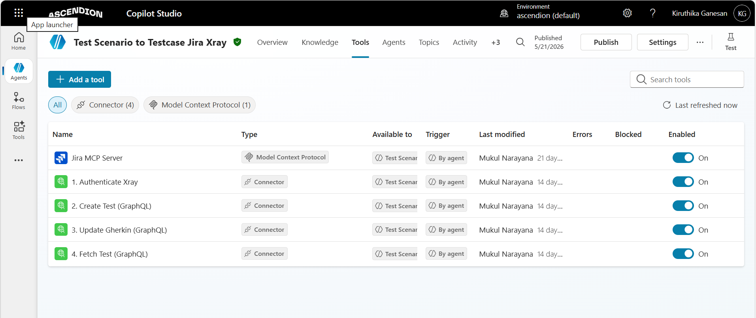
Integration
Jira MCP Server + Custom Xray Connector

Jira Domain
https://aavademo.atlassian.net
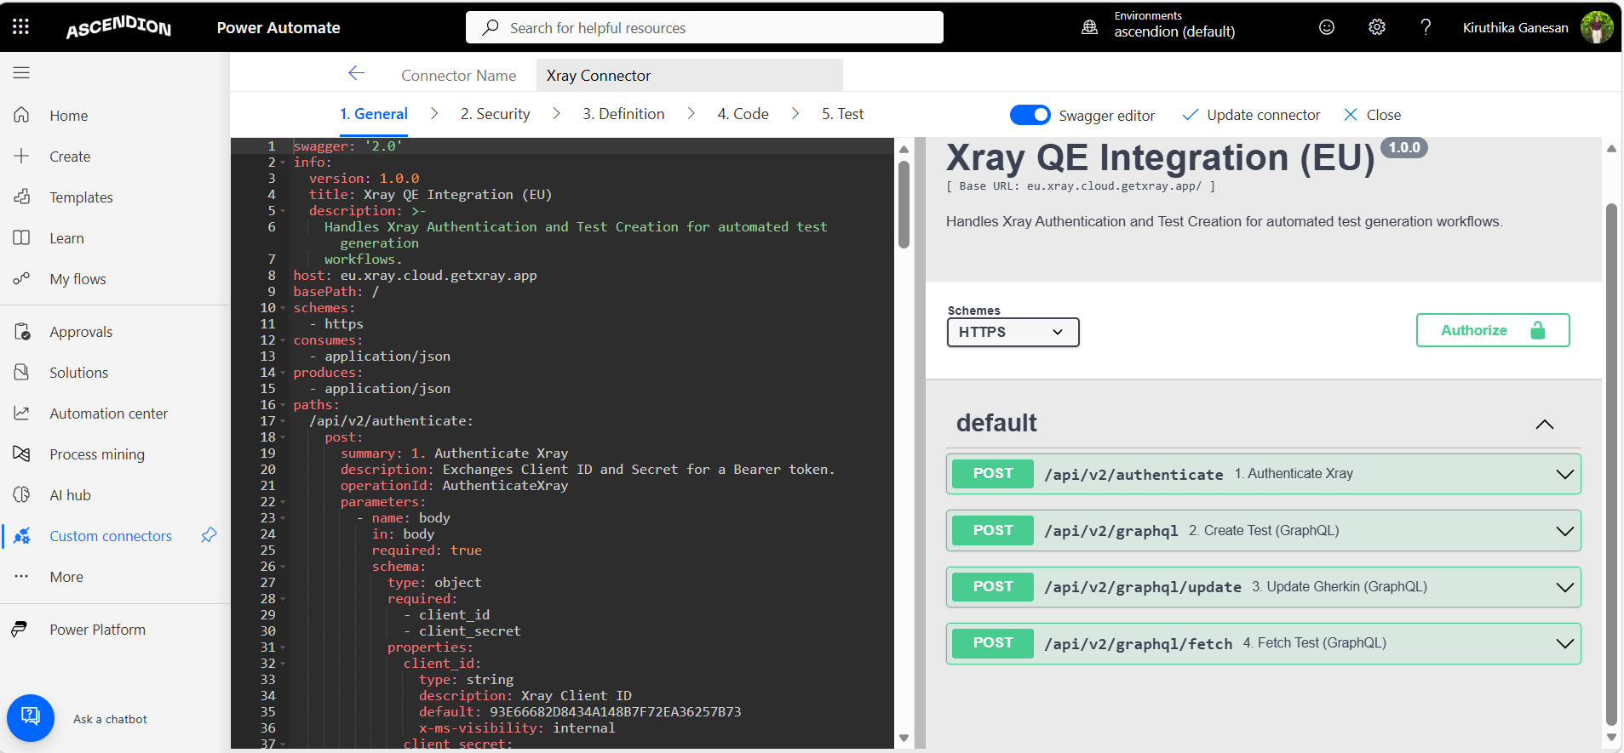

Summary Table:
Agent | Purpose | Tools Used
Jira Test Scenario Generator | Fetch user stories from Jira and create test scenario subtasks automatically | Jira MCP Server (get issue, create issue)
Test Scenario to Test Case Generator | Convert test scenarios into structured test cases and upload them to Xray in Jira | Jira MCP Server + Custom Xray Connector (Authenticate Xray, Create Test, Update Gherkin, Fetch Test)

OUTPUT:
